Chapter9 Uniprocessor Scheduling
Answers to Questions

9.1 Long-term scheduling: The decision to add to the pool of processes to be executed. Medium-term scheduling: The decision to add to the number of processes that are partially or fully in main memory. Short-term scheduling: The decision as to which available process will be executed by the processor

9.2 Response time.

9.3 Turnaround time is the total time that a request spends in the system (waiting time plus service time. Response time is the elapsed time between the submission of a request until the response begins to appear as output.

9.4 In UNIX and many other systems, larger priority values represent lower priority processes. Some systems, such as Windows, use the opposite convention: a higher number means a higher priority

9.5 Nonpreemptive: If a process is in the Running state, it continues to execute until (a) it terminates or (b) blocks itself to wait for I/O or to request some operating system service. Preemptive: The currently running process may be interrupted and moved to the Ready state by the operating system. The decision to preempt may be performed when a new process arrives, when an interrupt occurs that places a blocked process in the Ready state, or periodically based on a clock interrupt.

9.6 As each process becomes ready, it joins the ready queue. When the currently-running process ceases to execute, the process that has been in the ready queue the longest is selected for running.

9.7 A clock interrupt is generated at periodic intervals. When the interrupt occurs, the currently running process is placed in the ready queue, and the next ready job is selected on a FCFS basis.

9.8 This is a nonpreemptive policy in which the process with the shortest expected processing time is selected next.

9.9 This is a preemptive version of SPN. In this case, the scheduler always chooses the process that has the shortest expected remaining processing time. When a new process joins the ready queue, it may in fact have a shorter remaining time than the currently running process. Accordingly, the scheduler may preempt whenever a new process becomes ready.

9.10 When the current process completes or is blocked, choose the ready process with the greatest value of R, where R = (w + s)/s, with w = time spent waiting for the processor and s = expected service time.

9.11 Scheduling is done on a preemptive (at time quantum) basis, and a dynamic priority mechanism is used. When a process first enters the system, it is placed in RQ0 (see Figure 9.4). After its first execution, when it returns to the Ready state, it is placed in RQ1. Each subsequent time that it is preempted, it is demoted to the next lower-priority queue. A shorter process will complete quickly, without migrating very far down the hierarchy of ready queues. A longer process will gradually drift downward. Thus, newer, shorter processes are favored over older, longer processes. Within each queue, except the lowest-priority queue, a simple FCFS mechanism is used. Once in the lowest-priority queue, a process cannot go lower, but is returned to this queue repeatedly until it completes execution.

Answers to Problems
9.1 Each square represents one time unit; the number in the square refers to the currently-running process.

FCFS | A | A | A | B | B | B | B | B | C | C | D | D | D | D | D | E | E | E | E | E
RR, q = 1 | A | B | A | B | C | A | B | C | B | D | B | D | E | D | E | D | E | D | E | E
RR, q = 4 | A | A | A | B | B | B | B | C | C | B | D | D | D | D | E | E | E | E | D | E
SPN | A | A | A | C | C | B | B | B | B | B | D | D | D | D | D | E | E | E | E | E
SRT | A | A | A | C | C | B | B | B | B | B | D | D | D | D | D | E | E | E | E | E
HRRN | A | A | A | B | B | B | B | B | C | C | D | D | D | D | D | E | E | E | E | E
Feedback, q = 1 | A | B | A | C | B | C | A | B | B | D | B | D | E | D | E | D | E | D | E | E
Feedback, q = 2i | A | B | A | A | C | B | B | C | B | B | D | D | E | D | D | E | E | D | E | E

 |  | A | B | C | D | E
 | Ta | 0 | 1 | 3 | 9 | 12
 | Ts | 3 | 5 | 2 | 5 | 5
FCFS | Tf | 3 | 8 | 10 | 15 | 20
 | Tr | 3.00 | 7.00 | 7.00 | 6.00 | 8.00 | 6.20
 | Tr/Ts | 1.00 | 1.40 | 3.50 | 1.20 | 1.60 | 1.74
RR q = 1 | Tf | 6.00 | 11.00 | 8.00 | 18.00 | 20.00
 | Tr | 6.00 | 10.00 | 5.00 | 9.00 | 8.00 | 7.60
 | Tr/Ts | 2.00 | 2.00 | 2.50 | 1.80 | 1.60 | 1.98
RR q = 4 | Tf | 3.00 | 10.00 | 9.00 | 19.00 | 20.00
 | Tr | 3.00 | 9.00 | 6.00 | 10.00 | 8.00 | 7.20
 | Tr/Ts | 1.00 | 1.80 | 3.00 | 2.00 | 1.60 | 1.88
SPN | Tf | 3.00 | 10.00 | 5.00 | 15.00 | 20.00
 | Tr | 3.00 | 9.00 | 2.00 | 6.00 | 8.00 | 5.60
 | Tr/Ts | 1.00 | 1.80 | 1.00 | 1.20 | 1.60 | 1.32
SRT | Tf | 3.00 | 10.00 | 5.00 | 15.00 | 20.00
 | Tr | 3.00 | 9.00 | 2.00 | 6.00 | 8.00 | 5.60
 | Tr/Ts | 1.00 | 1.80 | 1.00 | 1.20 | 1.60 | 1.32
HRRN | Tf | 3.00 | 8.00 | 10.00 | 15.00 | 20.00
 | Tr | 3.00 | 7.00 | 7.00 | 6.00 | 8.00 | 6.20
 | Tr/Ts | 1.00 | 1.40 | 3.50 | 1.20 | 1.60 | 1.74
FB q = 1 | Tf | 7.00 | 11.00 | 6.00 | 18.00 | 20.00
 | Tr | 7.00 | 10.00 | 3.00 | 9.00 | 8.00 | 7.40
 | Tr/Ts | 2.33 | 2.00 | 1.50 | 1.80 | 1.60 | 1.85
FB | Tf | 4.00 | 10.00 | 8.00 | 18.00 | 20.00
q = 2i | Tr | 4.00 | 9.00 | 5.00 | 9.00 | 8.00 | 7.00
 | Tr/Ts | 1.33 | 1.80 | 2.50 | 1.80 | 1.60 | 1.81

9.2

FCFS | A | B | B | B | B | B | B | B | B | B | C | D | D | D | D | D | D | D | D | D
RR, q = 1 | A | B | C | B | D | B | D | B | D | B | D | B | D | B | D | B | D | B | D | D
RR, q = 4 | A | B | B | B | B | C | B | B | B | B | D | D | D | D | B | D | D | D | D | D
SPN | A | B | B | B | B | B | B | B | B | B | C | D | D | D | D | D | D | D | D | D
SRT | A | B | C | B | B | B | B | B | B | B | B | D | D | D | D | D | D | D | D | D
HRRN | A | B | B | B | B | B | B | B | B | B | C | D | D | D | D | D | D | D | D | D
Feedback, q = 1 | A | B | C | D | B | D | B | D | B | D | B | D | B | D | B | D | B | D | B | D
Feedback, q = 2i | A | B | C | D | B | B | D | D | B | B | B | B | D | D | D | D | B | B | D | D

 |  | A | B | C | D
 | Ta | 0 | 1 | 2 | 3
 | Ts | 1 | 9 | 1 | 9
FCFS | Tf | 1.00 | 10.00 | 11.00 | 20.00
 | Tr | 1.00 | 9.00 | 9.00 | 17.00 | 9.00
 | Tr/Ts | 1.00 | 1.00 | 9.00 | 1.89 | 3.22
RR q = 1 | Tf | 1.00 | 18.00 | 3.00 | 20.00
 | Tr | 1.00 | 17.00 | 1.00 | 17.00 | 9.00
 | Tr/Ts | 1.00 | 1.89 | 1.00 | 1.89 | 1.44
RR q = 4 | Tf | 1.00 | 15.00 | 6.00 | 20.00
 | Tr | 1.00 | 14.00 | 4.00 | 17.00 | 9.00
 | Tr/Ts | 1.00 | 1.56 | 4.00 | 1.89 | 2.11
SPN | Tf | 1.00 | 10.00 | 11.00 | 20.00
 | Tr | 1.00 | 9.00 | 9.00 | 17.00 | 9.00
 | Tr/Ts | 1.00 | 1.00 | 9.00 | 1.89 | 3.22
SRT | Tf | 1.00 | 11.00 | 3.00 | 20.00
 | Tr | 1.00 | 10.00 | 1.00 | 17.00 | 7.25
 | Tr/Ts | 1.00 | 1.11 | 1.00 | 1.89 | 1.25
HRRN | Tf | 1.00 | 10.00 | 11.00 | 20.00
 | Tr | 1.00 | 9.00 | 9.00 | 17.00 | 9.00
 | Tr/Ts | 1.00 | 1.00 | 9.00 | 1.89 | 3.22
FB q = 1 | Tf | 1.00 | 19.00 | 3.00 | 20.00
 | Tr | 1.00 | 18.00 | 1.00 | 17.00 | 9.25
 | Tr/Ts | 1.00 | 2.00 | 1.00 | 1.89 | 1.47
FB | Tf | 1.00 | 18.00 | 3.00 | 20.00
q = 2i | Tr | 1.00 | 17.00 | 1.00 | 17.00 | 9.00
 | Tr/Ts | 1.00 | 1.89 | 1.00 | 1.89 | 1.44

9.3 We will prove the assertion for the case in which a batch of n jobs arrive at the same time, and ignoring further arrivals. The proof can be extended to cover later arrivals.
Let the service times of the jobs be

t1 ≤ t2 ≤ . . . ≤ tn

Then, n users must wait for the execution of job 1; n – 1 users must wait for the execution of job 2, and so on. Therefore, the average response time is

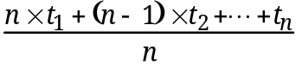

If we make any changes in this schedule, for example by exchanging jobs j and k (where j < k), the average response time is increased by the amount

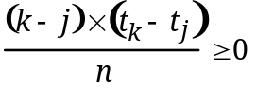

In other words, the average response time can only increase if the SPN algorithm is not used. Source: [BRIN73].

9.4 The data points for the plot:

Age of Observation | Observed Value | Simple Average | alpha = 0.8 | alpha = 0.5
1 | 6 | 0.00 | 0.00 | 0.00
2 | 4 | 3.00 | 4.80 | 3.00
3 | 6 | 3.33 | 4.16 | 3.50
4 | 4 | 4.00 | 5.63 | 4.75
5 | 13 | 4.00 | 4.33 | 4.38
6 | 13 | 5.50 | 11.27 | 8.69
7 | 13 | 6.57 | 12.65 | 10.84

9.5 The first equation is identical to Equation 9.3, so the parameter a provides an exponential smoothing effect. The parameter β is a delay variance factor (e.g., 1.3 to 2.0). A smaller value of β will result in faster adaptation to changes in the observed times, but also more fluctuation in the estimates.
A sophisticated analysis of this type of estimation procedure is contained in Applied Optimal Estimation, edited by Gelb, M.I.T. Press, 1974.

9.6 It depends on whether you put job A in a queue after the first time unit or not. If you do, then it is entitled to 2 additional time units before it can be preempted.

9.7 First, the scheduler computes the response ratios at time t + r1 + r2 + r3, when all three jobs will have been finished (see figure). At that time, job 3 will have the smallest response ratio of the three: so the scheduler decides to execute this job last and proceeds to examine jobs 1 and 2 at time t + r1 + r2, when they will both be finished. Here the response ratio of job 1 is the smaller, and consequently job 2 is selected for service at time t. This algorithm is repeated each time a job is completed to take new arrivals into account. Note that this algorithm is not quite the same as highest response ratio next. The latter would schedule job 1 at time t. Intuitively, it is clear that the present algorithm attempts to minimize the maximum response ratio by consistently postponing jobs that will suffer the least increase of their response ratios.
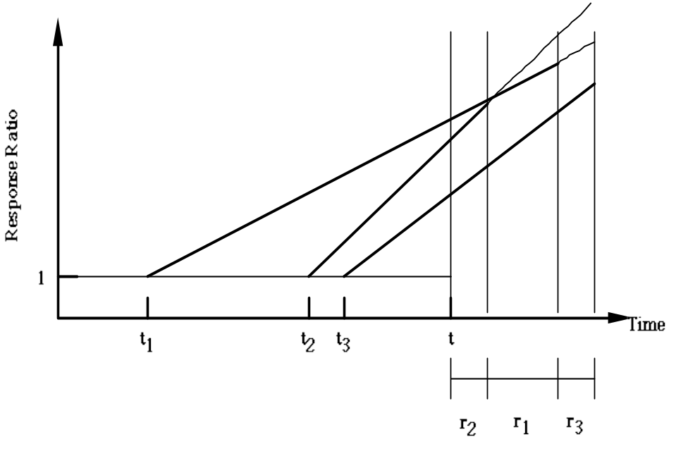
9.8 This proof, due to P. Mondrup, is reported in [BRIN73]. Consider the queue at time t immediately after a departure and ignore further arrivals. The waiting jobs are numbered 1 to n in the order in which they will be scheduled:

job: | 1 | 2 | . . . | i | . . . | n
arrival time: | t1 | t2 | . . . | ti | . . . | tn
service time: | r1 | r2 | . . . | ri | . . . | rn
Among these we assume that job i will reach the highest response ratio before its departure. When the jobs 1 to i have been executed, time becomes
Ti = t + r1 + r2 + . . . + ri
and job i has the response ratio
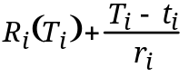
The reason for executing job i last in the sequence 1 to i is that its response ratio will be the lowest one among these jobs at time Ti:
Ri(Ti) = min [ R1(Ti), R2(Ti), . . . , Ri(Ti) ]

Consider now the consequences of scheduling the same n jobs in any other sequence:

job: | a | b | . . . | j | . . . | z
arrival time: | ta | tb | . . . | tj | . . . | tz
service time: | ra | rb | . . . | rj | . . . | rz

In the new sequence, we select the smallest subsequence of jobs, a to j, that contains all the jobs, 1 to i, of the original subsequence (This implies that job j is itself one of the jobs 1 to i). When the jobs a to j have been served, time becomes

Tj = t + ra + rb + . . . + rj

and job j reaches the response ratio

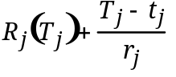

Since the jobs 1 to i are a subset of the jobs a to j, the sum of their service times Ti – t must be less than or equal to the sum of service time Tj – t. And since response ratios increase with time, Ti ≤ Tj implies

Rj(Tj) ≥ Rj(Ti)

It is also known that job j is one of the jobs 1 to i, of which job j has the smallest response ratio at time Ti. The above inequality can therefore be extended as follows:

Rj(Tj) ≥ Rj(Ti) ≥ Ri(Ti)

In other words, when the scheduling algorithm is changed, there will always be a job j that reaches response ratio Rj(Tj), which is greater than or equal to the highest response ratio Ri(Ti) obtained with the original algorithm.
Notice that this proof is valid in general for priorities that are non-decreasing functions of time. For example, in a FIFO system, priorities increase linearly with waiting time at the same rate for all jobs. Therefore, the present proof shows that the FIFO algorithm minimizes the maximum waiting time for a given batch of jobs.

9.9 Before we begin, there is one result that is needed, as follows. Assume that an item with service time Ts has been in service for a time h. Then, the expected remaining service time E [T/T > h] = Ts. That is, no matter how long an item has been in service, the expected remaining service time is just the average service time for the item. This result, though counter to intuition, is correct, as we now show.
Consider the exponential probability distribution function:

F(x) = Pr[X ≤ x] = 1 – e–µx

Then, we have Pr[X > x] = e-µx. Now let us look at the conditional probability that X is greater than x + h given that X is greater than x:
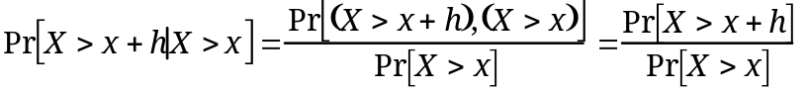
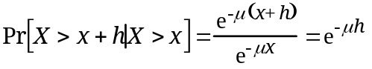
So,
Pr[X ≤ x + h/X > x] = 1 – e–µh = Pr[X ≤ h]
Thus the probability distribution for service time given that there has been service of duration x is the same as the probability distribution of total service time. Therefore the expected value of the remaining service time is the same as the original expected value of service time.
With this result, we can now proceed to the original problem. When an item arrives for service, the total response time for that item will consist of its own service time plus the service time of all items ahead of it in the queue. The total expected response time has three components.

•Expected service time of arriving process = Ts
•Expected service time of all processes currently waiting to be served. This value is simply w × Ts, where w is the mean number of items waiting to be served.
•Remaining service time for the item currently in service, if there is an item currently in service. This value can be expressed as ρ × Ts, where ρ is the utilization and therefore the probability that an item is currently in service and Ts, as we have demonstrated, is the expected remaining service time.

Thus, we have

9.10 Let us denote the time slice, or quantum, used in round robin scheduling as δ. In this problem, δ is assumed to be very small compared to the service time of a process. Now, consider a newly arrived process, which is placed at the end of the ready queue for service. We are assuming that this particular process has a service time of x, which is some multiple of δ:

x = mδ

To begin, let us ask the question, how much time does the process spend in the queue before it receives its first quantum of service. It must wait until all q processes waiting in line ahead of it have been serviced. Thus the initial wait time = qδ, where q is the average number of items in the system (waiting and being served). We can now calculate the total time this process will spend waiting before it has received x seconds of service. Since it must pass through the active queue m times, and each time it waits qδ seconds, the total wait time is as follows:

Wait time = m (qδ)
= 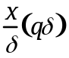
= qx

Then, the response time is the sum of the wait time and the total service time

Rx = wait time + service time
= qx + x = (q + 1) x

Referring to the queuing formulas in Appendix A, the mean number of items in the system, q, can be expressed as

Thus,

9.11 An argument in favor of a small quantum: Using a small quantum will enhance responsiveness by frequently running all processes for a short time slice. When the ready queue has many processes that are interactive, responsiveness is very important e.g. general-purpose computer system.
An argument in favor of a large quantum: Using a large quantum will enhance the throughput, and the CPU utilization measured with respect to real work, because there is less context switching and therefore less overhead. e.g. batch jobs.
A system for which both might be appropriate: There are some systems for which both small and large quanta are reasonable. e.g. a long job that requires just a few user interactions. Although this type of job can be considered as a batch job, in some sense, it still has to interact with the user. Therefore, during the times when there is no user interaction, the quantum might be increased to optimize the throughout and during interactive time, the quantum might be lowered to provide better responsiveness.

9.12 First, we need to clarify the significance of the parameter λ'. The rate at which items arrive at the first box (the "queue" box) is λ. Two adjacent arrivals to the second box (the "service" box) will arrive at a slightly slower rate, since the second item is delayed in its chase of the first item. We may calculate the vertical offset y in the figure in two different ways, based on the geometry of the diagram:
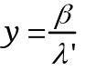

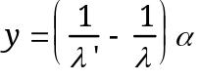
which therefore gives
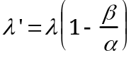

The total number of jobs q waiting or in service when the given job arrives is given by:
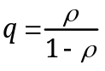

independent of the scheduling algorithm. Using Little's formula (see Appendix A):
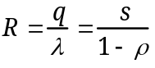

Now let W and Vx denote the mean times spent in the queue box and in the service box by a job of service time x. Since priorities are initially based only on elapsed waiting times, W is clearly independent of the service time x. Evidently we have
Rx = W + Vx

From problem 9.10, we have
where ρ' = λ's

By taking the expected values of Rx and Sx, we have R = W + V. We have already developed the formula for R. For V, observe that the arrival rate to the service box is l', and therefore the utilization is r'. Accordingly, from our basic M/M/1 formulas, we have
Thus,
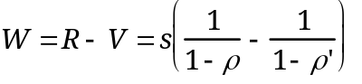

which yields the desired result for Rx.

9.13 Only as long as there are comparatively few users in the system. When the quantum is decreased to satisfy more users rapidly two things happen: (1) processor utilization decreases, and (2) at a certain point, the quantum becomes too small to satisfy most trivial requests. Users will then experience a sudden increase of response times because their requests must pass through the round-robin queue several times. Source: [BRIN73].

9.14 If a process uses too much processor time, it will be moved to a lower-priority queue. This leaves I/O-bound processes in the higher-priority queues.

9.15 Dekker's algorithm relies on the fairness of the hardware and the OS. The use of priorities risks starvation as follows. It may happen if P0 is a very fast repetitive process which, as it constantly finds flag [1] = false, keeps entering its critical section, while P1, leaving the internal loop in which it was waiting for its turn, cannot set flag [1] to true, being prevented from doing so by P0's reading of the variable (remember that access to the variable takes place under mutual exclusion).

9.16 a. Sequence with which processes will get 1 min of processor time:

1 | 2 | 3 | 4 | 5 | Elapsed time
A  A  A  A  A  A  A  A  A  A  A  A  A  A  A | B  B  B  B  B  B  B  B  B | C  C  C | D  D  D  D  D  D | E  E  E  E  E  E  E  E  E  E  E  E | 5  10  15  19  23  27  30  33  36  38  40  42  43  44  45

The turnaround time for each process:
A = 45 min, B = 35 min, C = 13 min, D = 26 min, E = 42 min
The average turnaround time is = (45+35+13+26+42) / 5 = 32.2 min

b.
Priority | Job | Turnaround Time
3  4  6  7  9 | B  E  A  C  D | 9  9 + 12 = 21  21 + 15 = 36  36 + 3 = 39  39 + 6 = 45

The average turnaround time is: (9+21+36+39+45) / 5 = 30 min

c.
Job | Turnaround Time
A  B  C  D  E | 15  15 + 9 = 24  24 + 3 = 27  27 + 6 = 33  33 + 12 = 45

The average turnaround time is: (15+24+27+33+45) / 5 = 28.8 min

d.
Running Time | Job | Turnaround Time
3  6  9  12  15 | C  D  B  E  A | 3  3 + 6 = 9  9 + 9 = 18  18 + 12 = 30  30 + 15 = 45

The average turnaround time is: (3+9+18+30+45) / 5 = 21 min

